WE ARE SUPER CITIZENS
Introducción:

1. What do you do in school every day?
¿Qué haces en la escuela todos los días?
- I study. — Yo estudio.
- I learn new things. — Aprendo cosas nuevas.
- I read and write. — Leo y escribo.
- I do my homework. — Hago mi tarea.
- I go to class. — Voy a clase.

2. Do you listen to the teacher?
¿Escuchas al profesor?
- Yes, I do. — Sí.
- Yes, I listen carefully. — Sí, escucho con atención.
- Yes, I pay attention. — Sí, presto atención.
- Sometimes I listen. — A veces escucho.
- Yes, because I want to learn. — Sí, porque quiero aprender.

3. Do you help your classmates?
¿Ayudas a tus compañeros?
- Yes, I do. — Sí.
- Yes, I help them. — Sí, los ayudo.
- I help my friends with homework. — Ayudo a mis amigos con la tarea.
- Sometimes I help. — A veces ayudo.
- Yes, when they need me. — Sí, cuando me necesitan.

4. What happens if someone breaks rules?
¿Qué pasa si alguien rompe las reglas?
- They get in trouble. — Se meten en problemas.
- The teacher talks to them. — El profesor habla con ellos.
- They get a warning. — Reciben una advertencia.
- They must say sorry. — Deben pedir perdón.
- They lose points or privileges. — Pierden puntos o privilegios.

🟡 2. MINI ENSEÑANZA DEL CONCEPTO – 10 MIN- DIAPO

📌 Frases clave con traducción ampliada
- A good citizen is a person who follows rules.
— Un buen ciudadano es una persona que sigue las reglas y respeta las normas establecidas.
- A good citizen helps others.
— Un buen ciudadano ayuda a los demás cuando lo necesitan y coopera con las personas a su alrededor.
- A good citizen is kind and responsible.
— Un buen ciudadano es amable, respetuoso y responsable con sus acciones y decisiones.

📌 Aplicación en la escuela
- In school, we are good citizens.
— En la escuela, nosotros somos buenos ciudadanos porque actuamos de manera correcta y respetamos a los demás.
- We follow rules in the classroom.
— Seguimos las reglas dentro del salón de clases para convivir mejor y mantener un ambiente ordenado.

🟡 3. VOCABULARIO EXPANDIDO – 15 MIN
No solo palabras, sino contexto + frase.
- citizen → “I am a good citizen in school”
- rules → “We follow rules in class”
- help → “I help my classmates”
- kind → “I am kind to others”
- responsibility → “I have responsibility in school”
- classroom → “This is my classroom”
- school → “I go to school”
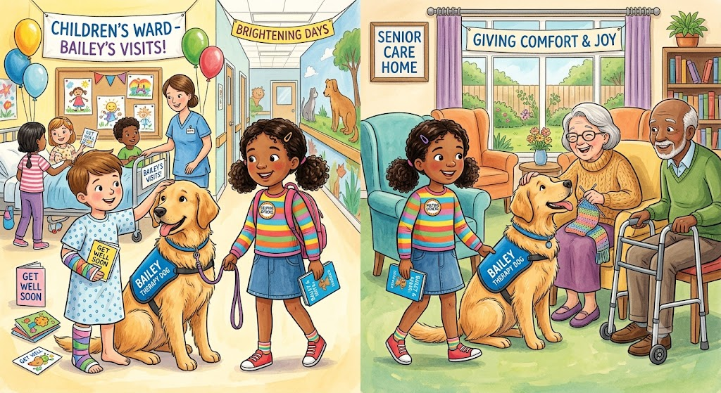
- safe → “We are safe in school”

✏️ 1. WARM UP ESCRITO (10 min)
👉 En el cuaderno
Activity 1: Answer with YES / NO
- I follow rules in school. ___
- I run in the classroom. ___
- I help my classmates. ___
- I listen to my teacher. ___
✔ Aquí ya empiezas escritura desde el inicio

✏️ 2. VOCABULARIO ESCRITO (15 min)
Activity 2: Match
Une con flecha o escribe la letra correcta:
A. rules
B. help
C. school
D. kind
- ___ ayudar
- ___ escuela
- ___ reglas
- ___ amable

✏️ 3. FRASES GUIADAS (15 min)
Activity 3: Complete the sentences
- I am a good __________ (citizen / student)
- I follow __________ in school (rules / games)
- I help my __________ (friends / toys)
- I am __________ in class (kind / fast)

✏️ 4. ORDENAR FRASES (15 min)
Activity 4: Unscramble
- citizen / I / a / good / am
→ ___________________________
- rules / I / follow
→ ___________________________
- people / I / help
→ ___________________________

✏️ 5. COMPRENSIÓN DEL TEXTO (15 min)
Activity 5: Answer short questions
(Respuestas cortas o selección)
- What do good citizens do?
→ a) break rules
→ b) follow rules
- Is helping others good?
→ Yes / No
- Where are we good citizens?
→ school / home / park

✏️ 6. PRODUCCIÓN FINAL (10–15 min)
Activity 6: Mini writing
👉 “I am a super citizen”
Completa:
I am a super citizen.
I __________ rules.
I __________ my classmates.
I am __________ in school.

🦸 WE ARE SUPER CITIZENS

Multiple Choice Questions

1. What does a good citizen do?
A. Breaks the rules
B. Helps others and follows rules
C. Ignores people
D. Shouts in class

2. Why is it important to follow classroom rules?
A. To make the classroom safe and organized
B. To finish school early
C. To make noise
D. To avoid homework

3. Which action shows responsibility?
A. Leaving trash on the floor
B. Taking care of school materials
C. Running in the classroom
D. Interrupting the teacher

4. What should you do if a classmate needs help?
A. Laugh at them
B. Ignore them
C. Help them if you can
D. Walk away

5. Which sentence describes a super citizen?
A. A super citizen is rude.
B. A super citizen is kind and respectful.
C. A super citizen breaks rules.
D. A super citizen does not help others.

6. How can students be good citizens at school?
A. By listening to the teacher and respecting others
B. By talking during lessons
C. By making fun of classmates
D. By refusing to work

7. What happens when everyone follows rules?
A. There is confusion.
B. There are more problems.
C. The classroom works better.
D. Nobody learns.

8. Which is the best example of kindness?
A. Sharing supplies with a friend
B. Taking someone's pencil
C. Ignoring a new student
D. Being disrespectful

9. Why should we respect others?
A. To be a good citizen and build friendships
B. To get more homework
C. To avoid learning
D. To be louder

10. A super citizen is someone who ______.
A. only thinks about himself
B. helps make the community better
C. breaks classroom rules
D. never cooperates

Bonus Question (Higher Thinking)

11. Maria sees paper on the classroom floor. What should she do?
A. Leave it there
B. Tell someone else to pick it up
C. Pick it up and throw it away
D. Kick it under a desk

CRONOGRAMA
- Hacer la introducción
- Leer la historia 2 veces resolver dudas si es necesario
- Actividad comprensión lectora
- Explicar la historia a partir de las diapositivas
- Vocabulario aprendido
- Demas actividades propuestas

